Number Basics

https://www.facebook.com/events/145076532854369/

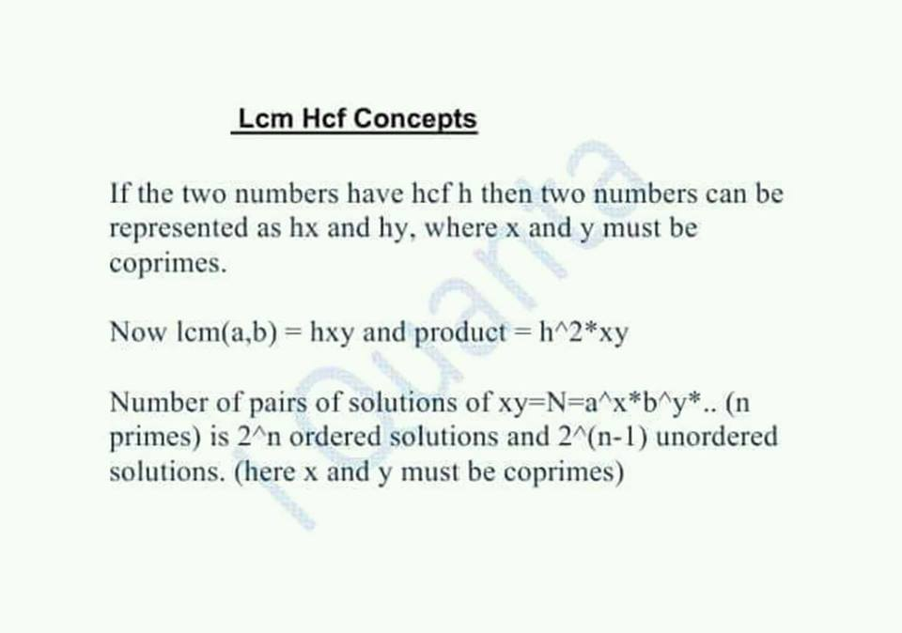

Q. Two number with hcf 8, and lcm 62832, then number of pairs will be ?

 Oa : 16  
  
solution : let 8x and 8y be the numbers   
  
and lcm = 8xy = 62832  
  
xy = 7854, = 2*3*7*11*17, total 5 primes   
  
so 2^(5-1) = 16 pairs.

32 ordered 16 unordedred  
  
Remember : whenever variables aren't mentioned we take unordered . And when mentioned we take ordered.

[**Kirti Tripathi**](https://www.facebook.com/kirti.tripathi.1426) variables aren't mentioned? sir ye ni smgha

[**Ashay Shashikumar Borkar**](https://www.facebook.com/ashay.borkar.7) [Kirti Tripathi](https://www.facebook.com/kirti.tripathi.1426?hc_location=ufi) they havent mentioned in terms of a and b, the have just asked no of pairs

3. Q. Number of pairs (x,y) such that their hcf is 17 and lcm is 3570 is ?

lcm = 17xy = 3570

xy = 210

Prime of 210 = 2,3,5,7

unordered pairs = 2^(4-1) = 2^3 = 8.

ordered pairs = 2^4 = 16.

(x,y) mentioned in the question means they want ordered.

ans : 16

Oa: 16  
  
Solution : Let the two numbers be 17x and 17y   
  
So , Lcm =17*xy=3570  
  
xy = 2*3*5*7  
  
number of primes = 4  
  
Number of solutions = 2^4= 16

4. Q. How many pairs (a,b) having hcf as 7 and their product as 12600 ?

Oa: 0 [#Troll](https://www.facebook.com/hashtag/troll?hc_location=ufi) Question  
  
Solution : Let the two numbers be 7x and 7y   
  
So , 7x*7y= 7^2*xy=12600  
  
xy = not integer   
  
Hence never possible.   
  
This question is an example of variables mentioned. So if the solution was possible it would have been ordered

Ordered pairs => arranged form

unordered pairs => not arranged

Ex: (1,2) and (2,1) are 2 ordered pairs while its 1 unordered pair

5.Derrivation

Whenever we assume two numbers as hx and hy , where h =HCF, x and y must always be coprime .

So after getting the final equation as xy=N , where x and y needs to be coprime. .

Here primes of N can go to any two of the numbers in 2*2...n times . =2^n ways. (Ordered )

Unordered : 2^n/2 = 2^(n-1).

● ordered just means arranged form while unordered is unarranged form.

Example:

Suppose there are 4 primes. Which needs to be distributed to the 2 numbers a and b.

The first prime has 2 choices. 2 ways   
Second has 2 choice. Similarly 3 n 4th

So Total 2*2*2*2 =2^4 ordered.

So if there were n primes then 2^n ordered and 2^(n-1) Unordered

Basic concept: Producf of Hcf and Lcm of two numbers = Product of the two numbers

Hcf*Lcm = Product of numbers

Ex: If there are two numbers hx and hy, where h = Hcf , and Lcm = hxy . Then

Then h * (hxy) = ( hx)(hy)

Agreed ?

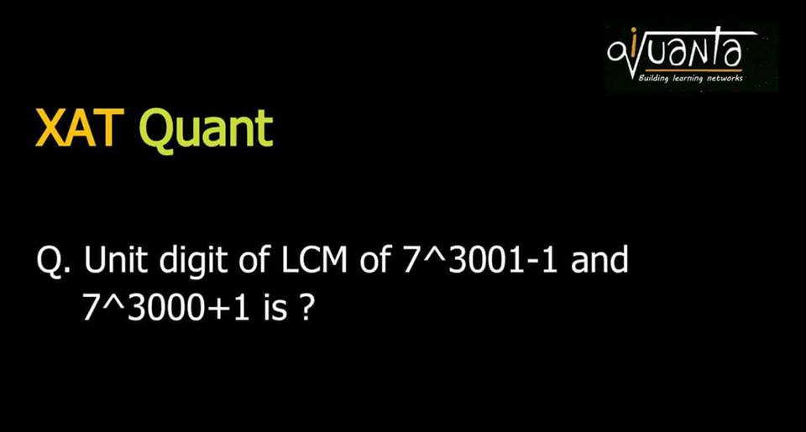

It is a tough question, should not have posted in class I think. Still:   
  
Hcf*Lcm = Product of numbers  
  
Now both are even numbers : Check if both divisible by 4 or not  
  
Nahi h.. so HCF 2 https://static.xx.fbcdn.net/images/emoji.php/v9/f9f/1/16/1f61b.png:p  
  
2*Lcm = [7^(3001)-1][7^3000+1]  
  
= 7^6001 +7^3001-7^3000-1  
  
2*Lcm = 7 +7-1-1  
  
Lcm = (12/2)=6  
  
[Rajeev Ranjan](https://www.facebook.com/profile.php?id=100004364135870&hc_location=ufi) wins 100

CAT level:

Find the unit’s digit of LCM of   
13^501 – 1 and 13^501 + 1 ?

As two are consecutive eve numbers hence Hcf of 13^501 – 1 and 13^501 + 1 will be 2  
  
Lcm*hcf = product of nos  
2*LCM = (13^501 – 1)(13^501 +1)  
Lcm = (13^1002 – 1)/2  
  
Last digit of 13^1002  
= Last digit of 3^1002  
= Last digit of 3^(4k + 2)  
= 9  
  
Last digit of 13^1002 – 1 = 9 – 1 = 8  
Last digit of (13^1002 – 1)/2 = 8/2 = 4

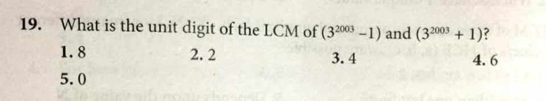

 Since both the numbers are consecutive even numbers..so hcf is 2  
  
And hcf*lcm = product of 2 numbers  
  
2*lcm = (3^2003-1)(3^2003+1)  
  
Lcm = (3^4006-1)/2  
  
Lcm = (9-1)/2= 4

sir what if in any question: 2*lcm=a number ending with zero. how will we do that coz there will be numerous possibilities ?

[Manage](https://www.facebook.com/events/145076532854369/145109596184396/?notif_t=admin_plan_mall_activity&notif_id=1517939395627718)

[Like](https://www.facebook.com/events/145076532854369/145109596184396/?notif_t=admin_plan_mall_activity&notif_id=1517939395627718)Show More Reactions

 · [Reply](https://www.facebook.com/events/145076532854369/145109596184396/?notif_t=admin_plan_mall_activity&notif_id=1517939395627718) · [1m](https://www.facebook.com/events/145076532854369/145109596184396/?comment_tracking=%7B%22tn%22%3A%22R9%22%7D)

[Indra Jeet](https://www.facebook.com/iquanta.iquanta)

[**Indra Jeet**](https://www.facebook.com/iquanta.iquanta) Find last 2 digits to get

Product of two natural number is 120 and their HCF is 24. What is the LCM of those two numbers

Indeterminate data. Not possible   
  
As hcf=24, so two numbers are 24a, 24b   
  
Product = 576ab   
  
576ab = 120  
  
ab = 5/24 , which is not possible

hcf = 59   
  
So two numbers are 59a and 59b  
(where a and b r co primes)  
  
lcm= 59ab =590  
  
ab = 10   
  
So 2^(2-1)= 2 pairs.   
  
Ps : Unorderd counted.

No automatic alt text available.

30^2003=2^2003x3^2003x5^2003  
  
Total factors : 2004^3   
  
20^2000=2^4000x5^2000  
  
hcf of both =2^2003x5^2000  
  
Factors of Hcf = factors common to both = 2004 x 2001  
  
Ans : Total - those common to both  
  
=> 2004^3-2004*2001

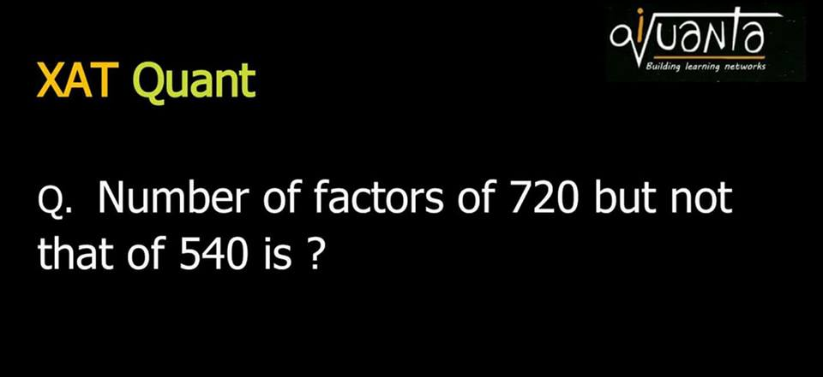

720 = 2^4 * 3^2 * 5 total factors = 5*3*2 = 30

540 = 2^2 * 3^3 * 5

HCF = 2^2 * 3^2 * 5 factors of hcf = 3*3*2 = 18

ans = total - factors of hcf = 30 - 18 = 12

720 = 2⁴ * 3² * 5   
  
540 = 2² *3³ * 5   
  
HCF ( 720,540) = 2² * 3² * 5  
  
Number of factors of 720 => 5 * 3 * 2 = 30   
  
Required : Factors of 720 - Factors common to 720 and 540  
  
Number of factors of HCF ( 720,540)   
= 3 *3 * 2 = 18   
  
Answer : 30 -18 = 12  
  
[#iQuanta](https://www.facebook.com/hashtag/iquanta?hc_location=ufi)

What is the HCF of 111...11 hundred ones and 111....111 sixty ones?

1111....20 times  
  
Hcf [ 1111....A times , 111...B times ]  
  
= 1111... Hcf [A,B] times  
  
So Hcf[100,60] = 20  
  
Ans 1111.... 20 times

1111 will always be divisible by 111....8 times or 111....12 times... or.... 111.... 4n times

there are two possible integer x and y such that their product is 69972 and hcf is 7...how many pair of(x,y) are possible?

Assignment:

1. The difference between LCM & HCF of two natural numbers a & b is 57. Wat is the minimum value of a+b?

2. Product of two numbers is 100 and lcm is 25 what is hcf?

3. If a = 72, hcf(a, b) = 16, lcm(a, b) = 216, then b = ?

4. HCF and LCM of A and B is 18 and 2268 respectively. How many pairs of (A,B) exists?

5.How many pairs of natural numbers exist that such that their HCF = 19 and their LCM = 5985?

6.The LCM of two numbers is 45 times their HCF. Sum of their HCF and LCM is 1150, Find the numbers?

7.Sum of LCM and HCF of two numbers is 33. How many pairs of such numbers satisfy these conditions ?

27 , 4 , np , 8 , 4 , 3 , 3

If lcm and hcf of two numbers are 2268 & 18. Find least possible sum of possible pairs.

Top of Form

If hcf = h   
  
Lcm = hxy   
  
So 18xy = 2268   
  
xy = 126 =9*14  
  
So 9+14= 23 was least possible   
  
But numbers are hx and hy not x and y   
  
So 23 x 18 = 414

a^n + b^n + c^n + d^n is divisible by a+b+c+d if   
  
1) n is odd.  
  
2) a,b,c,d are in AP   
  
As 2 conditions are followed hence N will be divisible by 16+17+18+19= 70   
  
Hence remainder 0  
  
[#iQuanta](https://www.facebook.com/hashtag/iquanta?hc_location=ufi)

6. The integers 34041 and 32506 when divided by a three-digit integer ‘n’ leave the same remainder. What is ‘n’?

TITA

34041-32506=1535...must be divisible by n... So 1535=307*5...so 307

 Any number= divisor* k + remainder  
  
So N1 = a*k + r   
N2 = b*c + r   
  
N1 - N2 = ak - bc   
  
That 3 digit must be divisible by ak - bc ( as remainder has been cancelled)   
  
Number must be factor of difference of the two numbers .   
  
34041-32506=1535  
  
Factor of 1535 which is 3 digit is 1535/5=307

 On dividing a number by 3, 4 and 7, the remainders are 2, 1 and 4 respectively. If the same number is divided by 84 then the remainder is

1) 80  
2) 76  
3) 53  
4) None of these

[**Indrajeet Singh**](https://www.facebook.com/indrajeetsinghrock) N = 3a +2 = 4b+1 = 7c +4   
  
First solve 3a+2= 4b+1   
=> 3a +1= 4b   
a=1 satisfies, so R = 3x1+2= 5   
N = 3*4k + 5 = 12k + 5   
  
Now 12k + 5 = 7c + 4   
=> 12k +1= 7c   
k =4 satisfies, R = 12x4 +5= 53   
  
So Oa : 53

[CAT 2003 Re-Test]

[#Remainder](https://www.facebook.com/hashtag/remainder?source=feed_text) Time : 2 mins

1.What is the remainder when 4^96 is divided by 6?

1) 0  
2) 2  
3) 3  
4) 4

[CAT 2004]

[#Remainders](https://www.facebook.com/hashtag/remainders?source=feed_text) : Time : 1 min

2. The remainder, when (15^23 + 23^23) is divided by 19, is:

1) 4  
2) 15  
3) 0  
4) 18

[CAT 2005]

[#Remainders](https://www.facebook.com/hashtag/remainders?source=feed_text) Time : 2 mins

3. If x = (16^3 + 17^3 + 18^3 + 19^3), then x divided by 70 leaves a remainder of

1) 0  
2) 1  
3) 69  
4) 35

4. Let n! = 1 × 2 × 3 × ... × n for integer n ≥ 1. If p = 1! + (2 × 2!) + (3 × 3!) + … +(10 × 10!), then p + 2 when divided by 11! leaves a remainder of

1) 10  
2) 0  
3) 7  
4) 1

[CAT 2000]

[#Remainder](https://www.facebook.com/hashtag/remainder?source=feed_text) Time : 20 secs

5. Let N = 1421 × 1423 × 1425. What is the remainder when N is divided by 12?

1) 0  
2) 9  
3) 3  
4) 6

[CAT 2000]

[#Remainder](https://www.facebook.com/hashtag/remainder?source=feed_text) Time : 2 mins

6. The integers 34041 and 32506 when divided by a three-digit integer ‘n’ leave the same remainder. What is ‘n’?

TITA

CAT 2002]

[#Remainders](https://www.facebook.com/hashtag/remainders?source=feed_text) Time : 2 mins

7. On dividing a number by 3, 4 and 7, the remainders are 2, 1 and 4 respectively. If the same number is divided by 84 then the remainder is

1) 80  
2) 76  
3) 53  
4) None of these

[CAT 2002]

[#Remainders](https://www.facebook.com/hashtag/remainders?source=feed_text) Time : 2 mins

8. For all integers n > 0, 7^6n – 6^6n is divisible by

1) 13  
2) 127  
3) 559  
4) All of these

(a-b)(a+b)= a^2 - b^2   
  
(a^3-b^3)(a^3+b^3)= a^6 - b^6  
  
7^6 - 6^6 is divisible by 7^3-6^3=127,  
7^3+6^3 = 559  
  
So divisible by 127, 559 and their factors too, ( 13 is a factor of 559)   
  
So Ans: divisible by All

[CAT 2002]

[#Remainder](https://www.facebook.com/hashtag/remainder?source=feed_text) Time : 1 min

9. The remainder when 2^256 is divided by 17 is

1) 7  
2) 13  
3) 11  
4) 1

195! divided by 394. Find remainder!

What is the remainder when 2^58 is divided by 24?

What is the remainder 347^347divided by100

Remainder.. 59^28 /7

13^101/360

Remainder when 37! is divided by 41 ?

10. 101! Mod 103 [ CAT 2003]

Q. 123123123.....(upto 123 digits)mod11

26^26^26mod35

Q. 3^81. What is the tens digit?

21^21^21mod25 ?

Find the remainder when 1!^3 + 2!^3 + 3!^3 + 4!^3 + . . .576!^3 is divided by 576